**Computer Certifications**

**3/17/2008**

**Tech Solutions, Inc.**

**IT Department**

Table of Contents

A Guide to Certification 3

Application Software Certification 3

Operating System Certifications 3

Programmer/Developer Certifications 4

Hardware Certifications 5

Networking Certifications 6

Internet Certifications 6

Security Certifications 6

Preparing for Certification 7

Table of Figures 8

Index 9

# A Guide to Certification

Certification is the process of verifying the technical knowledge of an individual who has demonstrated competence in a particular area. Certification demonstrates the mastery of a skill set and knowledge base in a specific IT area. Today, more than 200 certifications are available. Some certifications have a broad focus, and others require an in-depth knowledge of a single computing aspect. Often a sponsor establishes a series of related certifications to show levels of expertise within a single area.

Certifications usually are classified based on the computer industry area to which they most closely relate: application software, operating systems, programming, hardware, networking, computer forensics, security, the Internet, and database systems. Some certifications are related to more than one category. For example, a certification in networking also may indicate knowledge of hardware and operating systems.

Certifications are not the same with respect to training and options. Selecting a certification is a personal process that requires careful thought and research.

If you are new to the computer field, it is best to start with a general, entry-level certification. You may want to choose a certification that has immediate benefits for your current job.

This guide describes a few major certifications and certification sponsors in each industry area. Some certifications have components that span multiple categories. In this case, they are placed in the area for which they are known best.

## Application Software Certification

Although numerous types of application software exist, several applications have achieved national recognition for use as business and graphics tools. identifies some popular application software certifications, sometimes called end-user certifications, and their sponsors. Most sponsors of application software certifications have a partner training program and encourage computer training centers to be authorized training representatives.

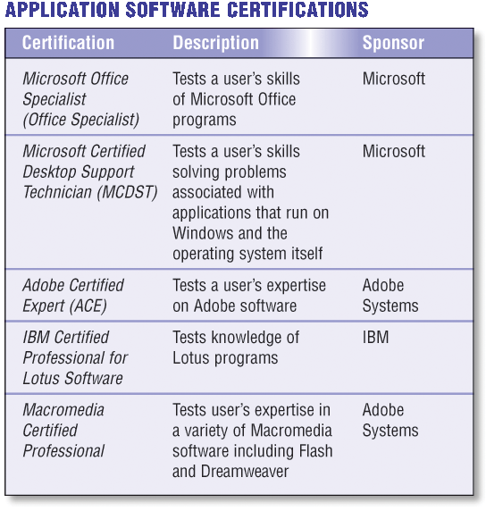

Figure : Application software certifications are available to anyone in the computer industry.

## Operating System Certifications

Several options for different knowledge levels are available to those seeking operating system certifications. These certifications focus on particular skills of the user, the operator, the system administrator, and the software engineer. The table in lists a few of the certifications available in the operating system area.

If you are interested in an occupation as an operating system administrator or software engineer, you also may benefit from certifications in networking, hardware, and the Internet. These additional certifications are linked closely to the operating system and serve to broaden expertise in that area.

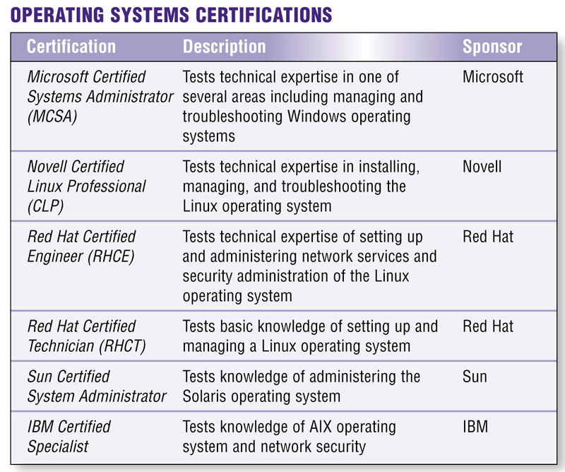

Figure : Operating system certifications test knowledge level of a specific operating system.

## Programmer/Developer Certifications

For programmer/developer certifications, several various areas are available. These certifications usually are supported with training programs that prepare applicants for the certification test.

If you are interested in writing application software, you also may benefit from certifications in networking and Web design. These certifications are tied closely to programming and may broaden employment opportunities.

The table shown identifies a few of the certifications available in the programmer/developer area.

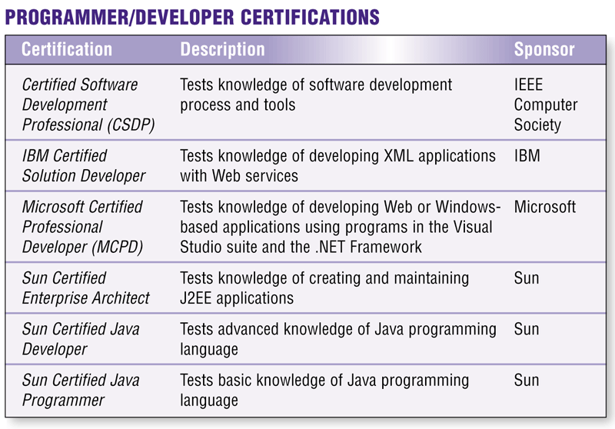

Figure : Various certifications are available in the programmer/developer area.

## Hardware Certifications

Hardware certifications vary in scope from a narrow focus with an emphasis on the repair of a specific device to an integrated hardware solution that addresses a company’s current and future computing needs. Obtaining an advanced certification in hardware implies that you have achieved a standard of competence in assessing a company’s hardware needs, and you can implement solutions to help the company achieve its computing goals.

People interested in hardware certifications also may benefit from networking and operating system software certifications, which are tied closely to advanced hardware knowledge. lists a few available hardware certifications.

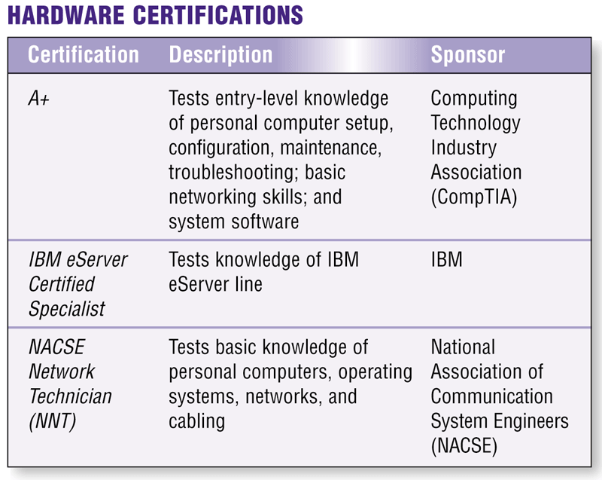

Figure : Hardware certifications may test general knowledge or knowledge of a specific type of hardware.

## Networking Certifications

Network expertise is acquired through years of experience and training because so many variables exist for a total network solution. Obtaining an advanced certification in networking implies that you have achieved a standard of competence, enabling you to address the complex issues that arise when planning, installing, managing, and troubleshooting a network. Networking certification holders can earn salary levels from 5 to 30 percent more than those without certification.

identifies a few of the certifications available in the networking area.

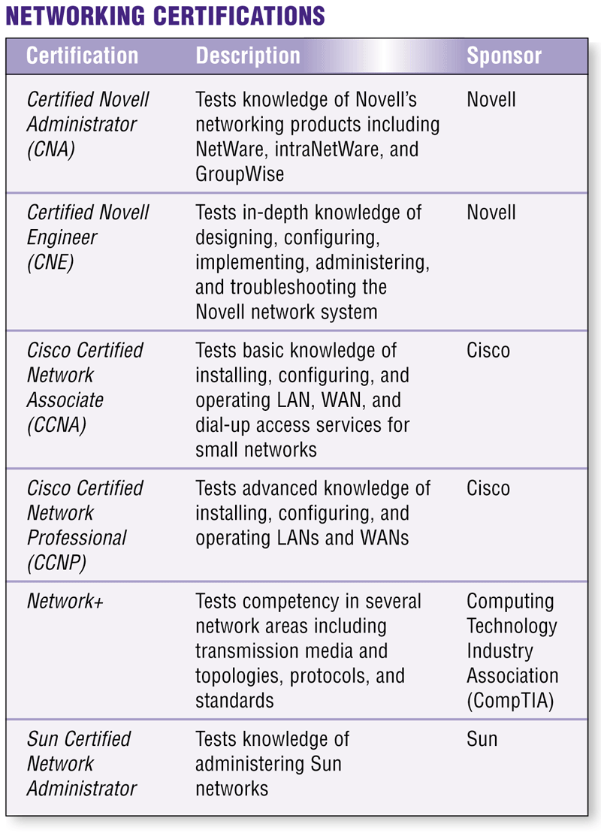

Figure : Networking certifications test knowledge of a company-specific network.

## Internet Certifications

Internet certifications are demanding and require technical expertise in networking hardware and configuration before enrollment in an Internet certification-sponsored training program. Internet certifications include Web management, Web programming, and Web development certifications.

Internet-related certifications also benefit from certifications in hardware, networking, operating systems, and programming.

## Security Certifications

Security certifications measure a candidate’s ability to identify and control security risks associated with any event or action that could cause a loss of or damage to computer hardware, software, data, information, or processing capability. While some security certifications focus solely on network and Internet security, others include measures to secure operating systems, application programs, and information systems, as well as the physical facility and its people.

The table shown in lists a few security certifications available.

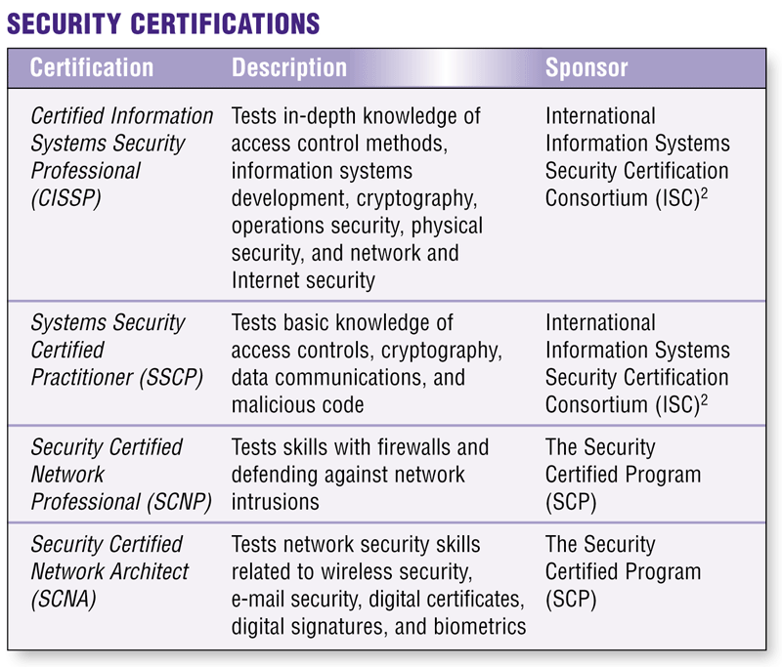

Figure : Some security certifications focus on network security, while others include security for the entire enterprise.

# Preparing for Certification

Most certifications programs do not require academic coursework. Test results alone determine certification. Very few professionals, however, have the experience and skill sets to take a certification exam without preparation. Most people prefer to follow a study program to prepare for the test. Even with experience, study serves as a review and may help to fill gaps in knowledge.

Training options are available to suit every learning style, including self-study, online training classes, instructor-led training, and Web resources.

Certifications are not the same with respect to training and options. Selecting a certification is a personal process that requires careful thought and research. If you are considering obtaining a certification, reflect on your career goals and interests. Consider your career path during the long term. Then, assess your background knowledge and experience. Finally, research certifications to find those that best match your needs.

If you are new to the computer field, it is best to start with a general, entry-level certification. You may want to choose a certification that has immediate benefits for your current job. Whatever you decide, remember: a certification represents a major commitment in time and money. Thoughtful research and planning can serve to guide your career to your chosen destination.

# Table of Figures

Figure 1: Application software certifications are available to anyone in the computer industry. 3

Figure 2: Operating system certifications test knowledge level of a specific operating system. 4

Figure 3: Various certifications are available in the programmer/developer area. 5

Figure 4: Hardware certifications may test general knowledge or knowledge of a specific type of hardware. 5

Figure 5: Networking certifications usually test knowledge of a company-specific network. 6

Figure 6: Some security certifications focus on network security, while others include security for the entire enterprise. 7

# Index

certification, 3

end-user certifications, 3

hardware certifications, 6

Internet certifications, 7

operating system certifications, 4

programmer/developer certifications, 5

security certifications, 8

software certifications, 3